# Homework 5 Subroutines

# 1. Describe briefly three advantages of using subroutines in programs. [6]

# 2. (a) What is a global variable? [1]

# (b) What is a local variable? [1]

# (c) What is the advantage of using local variables in subroutines? [2]

# 

# 3. Write a program in pseudocode that allows the user to add a name to a list array that holds up to ten names. The main program should call a subroutine that presents the user with a menu of three choices:

# 1 Add name

# 2 Display list

# 3 Quit

# The subroutine accepts and validates the user choice (1-3). If it is invalid, an appropriate error message should be displayed and the user asked to re-enter until they input a valid choice.

The subroutine is called with the statement

choice 🡨 displayMenu()

The main program then branches to one of two subroutines which adds a name or displays the list, or quits the program with a message “Program terminating” if the user selects option 3.

# 

# If the user chooses to add a name, they should be prompted to enter a list number indicating where they want the name to be inserted. If the location is occupied, it will overwrite the name.

# The program will also provides an option to display the list. The output should look something like the example below. [10]

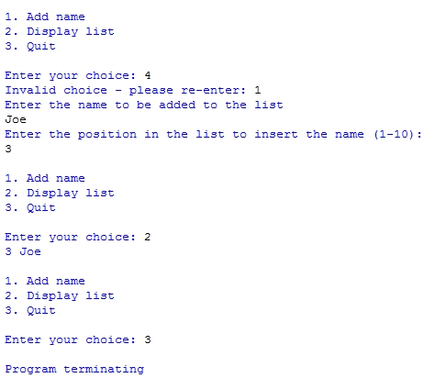

[Total 20 marks]